Experiment 4
Corner Detection Parameter Study
Image Feature Extraction, Detection & Matching Laboratory
C03-AT1
Name: PRAKASH.K
Reg. No: 192521081
Course: Computer Vision
Course Code: ITA0518
Faculty Name: Dr. T. Usha

Objective
To perform a systematic parameter-sensitivity study of the Harris corner detector, to explain the significance of each parameter in influencing corner-detection accuracy, and to analyze how parameter variation affects detection sensitivity and performance.

1. Understanding of Concepts
A corner is a point where the local image gradient changes significantly in two independent directions -- unlike an edge, where the gradient is strong in only one direction, or a flat region, where it is weak in all directions. Corners are especially valuable low-level features because they can be localized precisely and repeatably, which is essential for tasks like camera calibration, tracking and image registration.
The Harris detector formalizes 'corner-ness' by analyzing the local structure (autocorrelation) matrix M, built from the image's directional gradients (Ix, Iy) averaged over a local window. The eigenvalues of M describe how the local intensity changes in the two principal directions: two large eigenvalues indicate a corner, one large and one small indicate an edge, and two small eigenvalues indicate a flat region. Rather than computing eigenvalues directly, Harris uses the efficient corner-response function R = det(M) - k*trace(M)^2, which is large and positive at corners.
This experiment studies the three parameters that control cv2.cornerHarris: (1) blockSize -- the size of the neighbourhood window used to compute the local structure matrix M for each pixel; a larger window averages gradient statistics over a larger area, affecting both the scale of corners detected and robustness to noise. (2) ksize -- the aperture size of the Sobel operator used to compute Ix and Iy; a larger aperture produces a smoother, more large-scale gradient estimate, and also increases the raw gradient magnitude. (3) k -- the empirical Harris sensitivity constant (typically in the range 0.04-0.15) that controls how strongly the 'edge-like' term trace(M)^2 is penalized relative to det(M); larger k makes the detector stricter (fewer, more selective corners), smaller k makes it more permissive.

2. Experimental Design
- A synthetic 400x400 chessboard-style test scene (alternating light/dark squares, plus an overlaid rectangle and triangle for additional corner variety, with light Gaussian sensor noise, sigma=5) was generated so that a large, regularly-spaced, and visually verifiable set of true corners (all chessboard square intersections) exists as an intuitive ground truth.
- Three separate single-parameter sweeps were performed, changing only ONE parameter at a time while holding the other two fixed at reasonable defaults (blockSize=4, ksize=3, k=0.04), so that each parameter's individual effect can be isolated: (a) blockSize in {2, 4, 6, 10, 16}; (b) ksize in {3, 5, 7, 9, 11}; (c) k in {0.02, 0.04, 0.06, 0.10, 0.15}.
- For every parameter combination, the Harris response map was dilated and thresholded at 2% of its maximum value (a common relative-threshold convention for Harris) to obtain the final binary corner mask.
- Dependent variable: total number of detected corner pixels for each configuration, together with the visual corner overlay for qualitative inspection of WHERE corners appear/disappear, not just how many.

3. Use of Tools
- Python 3 as the implementation language.
- OpenCV (cv2) Harris corner detector (cv2.cornerHarris), morphological dilation (cv2.dilate) for response-map peak thickening, and drawing/synthesis functions (cv2.rectangle, cv2.fillPoly).
- NumPy for array thresholding, masking and the synthetic-scene noise.
- Matplotlib for the parameter-sweep image grids and the corner-count trend plots.
Complete implementation:
"""
Experiment 20: Corner Detection Parameter Study (Harris)
============================================================
Objective:
Perform a systematic parameter-sensitivity analysis of the Harris
corner detector: block size (neighbourhood window), Sobel aperture
(ksize) and the empirical sensitivity constant k.

Tools:
Python 3, OpenCV (cv2) cv2.cornerHarris, NumPy, Matplotlib

Output:
outputs/01_test_image.png - synthetic scene with known corners
outputs/02_blocksize_grid.png - effect of blockSize
outputs/03_ksize_grid.png - effect of Sobel aperture (ksize)
outputs/04_k_grid.png - effect of sensitivity constant k
outputs/05_metrics_plot.png - corner count vs each parameter
outputs/metrics.csv
"""

import os
import cv2
import numpy as np
import matplotlib
matplotlib.use("Agg")
import matplotlib.pyplot as plt

OUT = os.path.join(os.path.dirname(__file__), "outputs")
os.makedirs(OUT, exist_ok=True)
np.random.seed(5)

# ---------------------------------------------------------------------------
# 1. Test scene: chessboard-like pattern + polygons -> many well-defined corners
# ---------------------------------------------------------------------------
def make_scene(size=400):
img = np.full((size, size), 50, dtype=np.uint8)
step = 40
for i, y in enumerate(range(0, size, step)):
for j, x in enumerate(range(0, size, step)):
if (i + j) % 2 == 0:
cv2.rectangle(img, (x, y), (x + step, y + step), 220, -1)
cv2.rectangle(img, (150, 150), (260, 260), 130, -1)
pts = np.array([[300, 40], [370, 90], [340, 160]], np.int32)
cv2.fillPoly(img, [pts], 90)
noise = np.random.normal(0, 5, img.shape)
img = np.clip(img.astype(np.float32) + noise, 0, 255).astype(np.uint8)
return img

scene = make_scene()
plt.figure(figsize=(5, 5))
plt.imshow(scene, cmap="gray"); plt.title("Test scene (chessboard + shapes)"); plt.axis("off")
plt.tight_layout()
plt.savefig(os.path.join(OUT, "01_test_image.png"), dpi=150)
plt.close()

gray = np.float32(scene)

def harris_corners(gray_img, block_size, ksize, k, thresh_ratio=0.02):
dst = cv2.cornerHarris(gray_img, block_size, ksize, k)
dst_dilated = cv2.dilate(dst, None)
thresh = thresh_ratio * dst_dilated.max()
mask = dst_dilated > thresh
ys, xs = np.where(mask)
return mask, len(xs), dst

def overlay_corners(base_img, mask):
vis = cv2.cvtColor(base_img, cv2.COLOR_GRAY2BGR)
vis[mask] = [0, 0, 255]
return vis

rows = []

# ---------------------------------------------------------------------------
# 2. Vary blockSize (neighbourhood size), fix ksize=3, k=0.04
# ---------------------------------------------------------------------------
block_sizes = [2, 4, 6, 10, 16]
fig, axes = plt.subplots(1, len(block_sizes), figsize=(4 * len(block_sizes), 4.2))
for ax, bs in zip(axes, block_sizes):
mask, n, _ = harris_corners(gray, bs, 3, 0.04)
vis = overlay_corners(scene, mask)
rows.append({"study": "blockSize", "blockSize": bs, "ksize": 3, "k": 0.04, "num_corners": n})
ax.imshow(cv2.cvtColor(vis, cv2.COLOR_BGR2RGB))
ax.set_title(f"blockSize={bs}\n{n} corners", fontsize=10); ax.axis("off")
plt.tight_layout()
plt.savefig(os.path.join(OUT, "02_blocksize_grid.png"), dpi=150)
plt.close()

# ---------------------------------------------------------------------------
# 3. Vary ksize (Sobel aperture), fix blockSize=4, k=0.04
# ---------------------------------------------------------------------------
ksizes = [3, 5, 7, 9, 11]
fig, axes = plt.subplots(1, len(ksizes), figsize=(4 * len(ksizes), 4.2))
for ax, ks in zip(axes, ksizes):
mask, n, _ = harris_corners(gray, 4, ks, 0.04)
vis = overlay_corners(scene, mask)
rows.append({"study": "ksize", "blockSize": 4, "ksize": ks, "k": 0.04, "num_corners": n})
ax.imshow(cv2.cvtColor(vis, cv2.COLOR_BGR2RGB))
ax.set_title(f"ksize={ks}\n{n} corners", fontsize=10); ax.axis("off")
plt.tight_layout()
plt.savefig(os.path.join(OUT, "03_ksize_grid.png"), dpi=150)
plt.close()

# ---------------------------------------------------------------------------
# 4. Vary k (sensitivity constant), fix blockSize=4, ksize=3
# ---------------------------------------------------------------------------
ks_vals = [0.02, 0.04, 0.06, 0.10, 0.15]
fig, axes = plt.subplots(1, len(ks_vals), figsize=(4 * len(ks_vals), 4.2))
for ax, kval in zip(axes, ks_vals):
mask, n, _ = harris_corners(gray, 4, 3, kval)
vis = overlay_corners(scene, mask)
rows.append({"study": "k", "blockSize": 4, "ksize": 3, "k": kval, "num_corners": n})
ax.imshow(cv2.cvtColor(vis, cv2.COLOR_BGR2RGB))
ax.set_title(f"k={kval}\n{n} corners", fontsize=10); ax.axis("off")
plt.tight_layout()
plt.savefig(os.path.join(OUT, "04_k_grid.png"), dpi=150)
plt.close()

# ---------------------------------------------------------------------------
# 5. Metrics table + trend plots
# ---------------------------------------------------------------------------
import csv
with open(os.path.join(OUT, "metrics.csv"), "w", newline="") as f:
writer = csv.DictWriter(f, fieldnames=["study", "blockSize", "ksize", "k", "num_corners"])
writer.writeheader()
writer.writerows(rows)

fig, axes = plt.subplots(1, 3, figsize=(15, 4.5))
bs_rows = [r for r in rows if r["study"] == "blockSize"]
axes[0].plot([r["blockSize"] for r in bs_rows], [r["num_corners"] for r in bs_rows], "o-", color="teal")
axes[0].set_xlabel("blockSize"); axes[0].set_ylabel("Detected corners")
axes[0].set_title("Corners vs. blockSize"); axes[0].grid(alpha=0.3)

ks_rows = [r for r in rows if r["study"] == "ksize"]
axes[1].plot([r["ksize"] for r in ks_rows], [r["num_corners"] for r in ks_rows], "s-", color="darkorange")
axes[1].set_xlabel("ksize (Sobel aperture)"); axes[1].set_ylabel("Detected corners")
axes[1].set_title("Corners vs. ksize"); axes[1].grid(alpha=0.3)

k_rows = [r for r in rows if r["study"] == "k"]
axes[2].plot([r["k"] for r in k_rows], [r["num_corners"] for r in k_rows], "^-", color="crimson")
axes[2].set_xlabel("k (sensitivity constant)"); axes[2].set_ylabel("Detected corners")
axes[2].set_title("Corners vs. k"); axes[2].grid(alpha=0.3)
plt.tight_layout()
plt.savefig(os.path.join(OUT, "05_metrics_plot.png"), dpi=150)
plt.close()

print("Done. Results written to", OUT)
for r in rows:
print(r)

4. Results
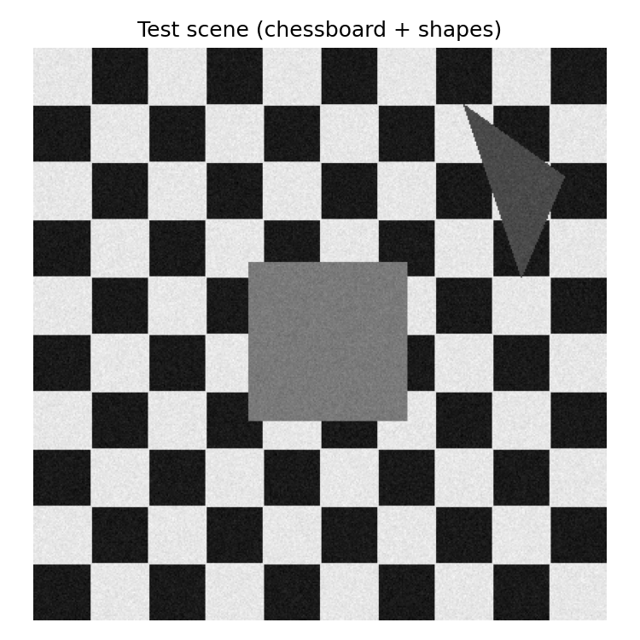
Figure 1. Synthetic chessboard-and-shapes test scene used for the parameter study.
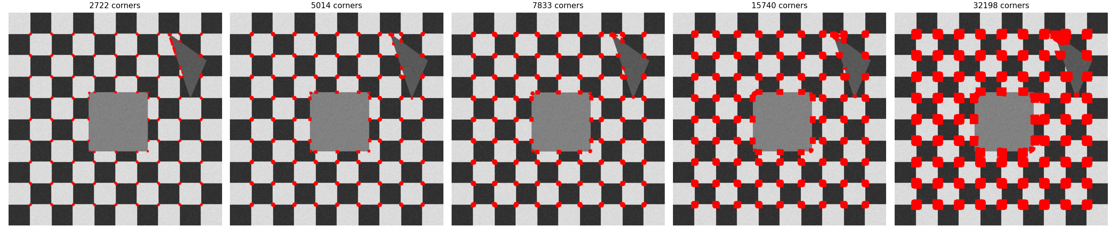
Figure 2. Detected corners (red) for blockSize in {2, 4, 6, 10, 16}, with ksize=3, k=0.04 held fixed.
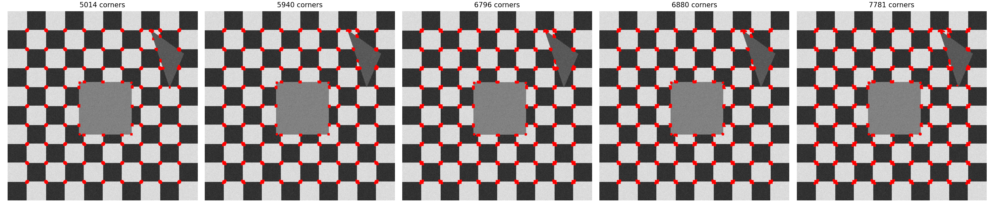
Figure 3. Detected corners for ksize in {3, 5, 7, 9, 11}, with blockSize=4, k=0.04 held fixed.
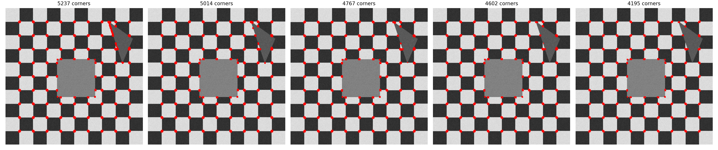
Figure 4. Detected corners for k in {0.02, 0.04, 0.06, 0.10, 0.15}, with blockSize=4, ksize=3 held fixed.
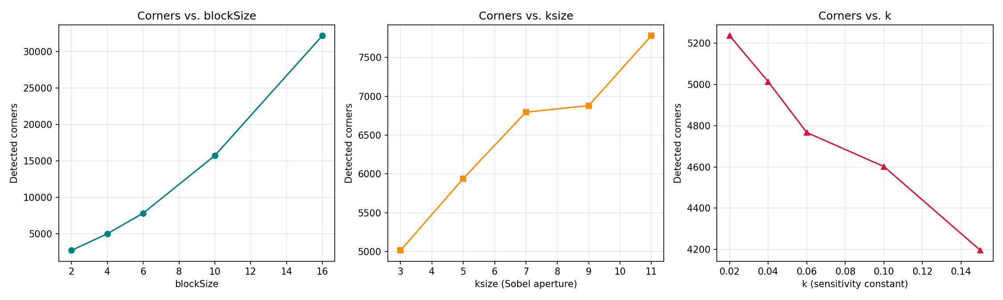
Figure 5. Number of detected corners plotted against each of the three parameters independently.
Summary of measured metrics:
Study | blockSize | ksize | k | # Corners
blockSize | 2 | 3 | 0.04 | 2722
blockSize | 4 | 3 | 0.04 | 5014
blockSize | 6 | 3 | 0.04 | 7833
blockSize | 10 | 3 | 0.04 | 15740
blockSize | 16 | 3 | 0.04 | 32198
ksize | 4 | 3 | 0.04 | 5014
ksize | 4 | 5 | 0.04 | 5940
ksize | 4 | 7 | 0.04 | 6796
ksize | 4 | 9 | 0.04 | 6880
ksize | 4 | 11 | 0.04 | 7781
k | 4 | 3 | 0.02 | 5237
k | 4 | 3 | 0.04 | 5014
k | 4 | 3 | 0.06 | 4767
k | 4 | 3 | 0.1 | 4602
k | 4 | 3 | 0.15 | 4195

5. Analysis of Results
blockSize had by far the strongest effect on corner count: it rose from 2,722 corners at blockSize=2 to 32,198 corners at blockSize=16 -- an 11.8x increase. Visually (Figure 2), small blockSize values produce crisp, well-localized, single-pixel-cluster responses exactly at the true chessboard intersections, while large blockSize values cause the response peaks to broaden and merge into thick blobs that spill across many neighbouring squares, degrading spatial precision even though more raw corner pixels are reported. This shows that blockSize trades off localization precision against noise-robustness/response strength.
ksize (Sobel aperture) had a smaller but still clearly monotonic effect, with corner count rising steadily from 5,014 at ksize=3 to 7,781 at ksize=11. A larger Sobel aperture computes gradients over a wider neighbourhood, which increases the raw gradient magnitude at true corners (and slightly at their surroundings), pushing more borderline pixels above the relative detection threshold. Unlike blockSize, the qualitative corner locations in Figure 3 remain visually well-aligned with the true chessboard grid across the whole ksize range tested, indicating ksize mainly affects sensitivity/threshold crossing rather than gross spatial precision.
k (the sensitivity constant) had the expected inverse relationship: increasing k from 0.02 to 0.15 reduced the corner count from 5,237 to 4,195, because larger k more heavily penalizes the trace(M)^2 (edge-like) term in the Harris response, making the detector progressively stricter and rejecting more ambiguous edge/corner-like points. This effect was the most modest of the three parameters over the ranges tested, but it offers the finest-grained, most predictable control over detector selectivity.
Taken together, the three parameters serve different practical roles: blockSize primarily controls the geometric SCALE and precision of detected corners, ksize primarily controls gradient-estimation SMOOTHNESS/SENSITIVITY, and k primarily controls the final SELECTIVITY threshold between corner-like and edge-like responses -- so tuning them together, rather than any single one in isolation, is necessary to match a detector to a given image scale and application.

6. Conclusion
- All three Harris parameters materially influence the number and spatial precision of detected corners, but blockSize has the largest effect by a wide margin in this study (11.8x range) compared to ksize (1.55x range) and k (only ~1.25x range, inversely).
- Small blockSize values are preferable when precise corner localization matters (e.g. camera calibration), while larger blockSize values increase raw response strength/robustness at the cost of spatial precision and can merge nearby true corners together.
- k provides fine, predictable control of detector strictness and is the natural parameter to tune first when adjusting sensitivity to noise/spurious corners, since it does not distort spatial localization the way blockSize does.
- In practice, Harris parameters should be selected jointly based on the expected corner scale in the target application and the acceptable trade-off between detection sensitivity and false-positive rate, rather than relying on default values.

7. Documentation
All source code, the synthetic test scene, every parameter-sweep image grid, and the raw corner-count metrics table (metrics.csv, covering all 15 parameter configurations tested) used to produce this report are included alongside this PDF in the accompanying corner_detection_parameter_study.py script and the outputs/ folder.

